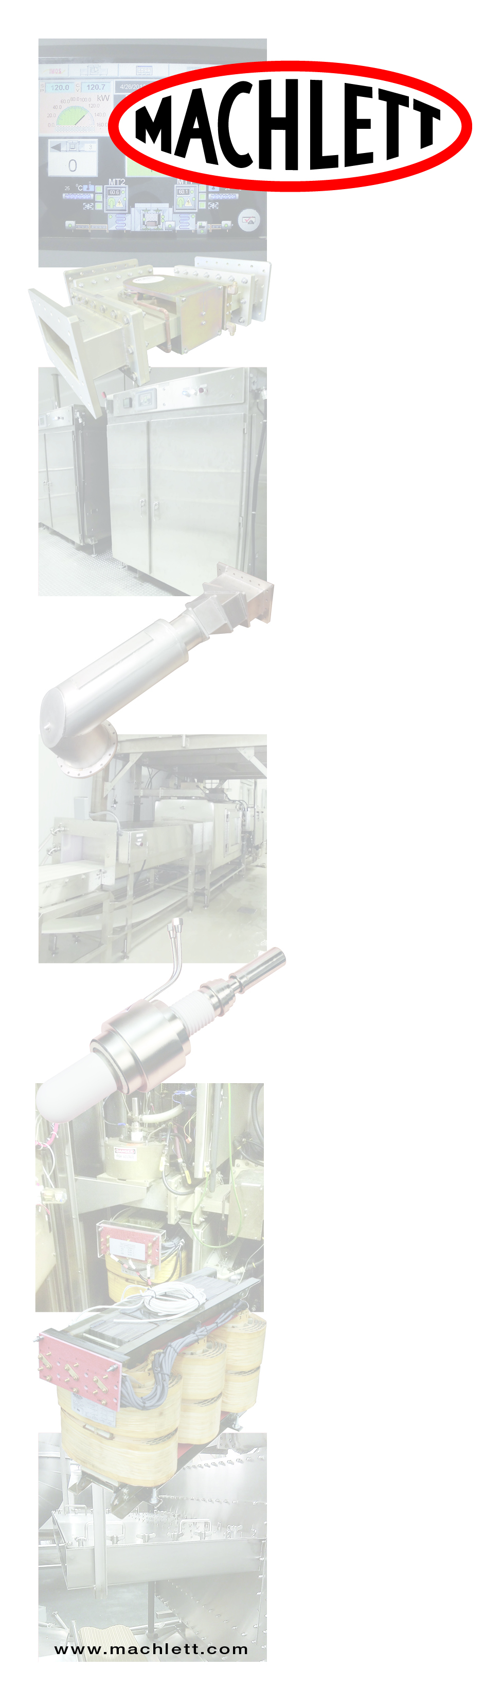

**Penta Labs/Machlett Microwave** 9740 Cozycroft Ave., Chatsworth, CA 91311 Office: 800-421-4219 ext. 205

**Industrial Microwave**

**Systems & Service**

